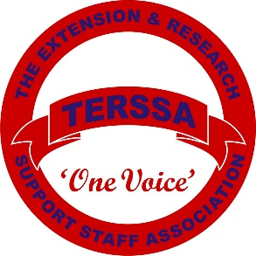  TERSSA Business Meeting  September 21, 2022  Kitty Hawk, NC |  |  |  | 2022 Officers  Becky Castello, NC – President  Faye Wilson, OH – President-Elect  Cheryl Duplechain, LA – Membership Secretary  Karen Bixler, AL – Recording Secretary  Cathy James, NC – Treasurer  Sandra Walton, AL - Webmaster  Christine Barrier, NC - Annalist  Christine Byrd, OH – Past President/Advisor  Christine Barrier, NC - Parliamentarian
AGENDA
Agenda Item |  | Discussion |  |  |  |  | Outcomes and Next Steps
Call to Order  Becky Castello, NC |  | Call to Order time:
Roll Call
Cheryl Duplechain, LA
Parliamentary Review  Christine Barrier, NC |  | Verify Quorum Verified: Not Verified:
Approval of Agenda  Becky Castello, NC |  | Removals/Additions |  |  | Motion:  Seconded:  Decision
Financial Report
Cathy James, NC
Approval of Minutes  Becky Castello, NC |  |  |  |  | Motion:  Seconded:  Decision:
REPORTS
Agenda Item |  |  | Discussion |  |  |  | Outcomes and Next Steps
Finance Committee
Cathy James, NC
Bylaws Committee
Faye Wilson, OH
Public Relations
Theresa Tilton, ME
Webmaster
Sandra Walton, AL
Nominating
Marla Jones, LA
Awards
Faye Wilson, OH
Scholarship
Marianne Guthrie, OH
Membership
Cheryl Duplechain, LA
Outreach & Marketing
Christine Barrier, NC
Annalist
Christine Barrier, NC
OLD BUSINESS
Other Old Business |  |  |  |  |  |  | Motion:  Seconded:  Decision:
NEW BUSINESS
Registration Giveaway  Becky Castello, NC |  |  |  |  |  | Motion:  Seconded:  Decision:
Other New Business |  |  |  |  |  | Motion:  Seconded:  Decision:
Induction of Officers  Marla Jones, LA |  |  |  |  |  | Motion:  Seconded:  Decision:
Invitation for 2023 Conference
Faye Wilson, OH
Adjournment
Adjourn | Motion:  Seconded:  Time:

Meeting Notes:

